**DEVELOPER MANUAL**

**FOR**

**CODEWORD GENERATOR**

**(ANGULAR)**

**Table of Contents**

Structure of Application 3

Tools and Technologies Used 3

Installation instruction 4

Set up the Development Environment 18

Steps to run application 18

**Structure of application:**

|  |  |
| --- | --- |
| config/database.js | Connecting the application with the mongo DB |
| controllers/ | Handles what response to send back to a user when a user makes a browser request. Its JavaScript which handles all requests and renders responses |
| model/ | It represents domain specific data and business logic and maintains the data of the application. |
| routers/user.router.js | Route definitions for the API |
| views/src/app/ | It has typescript, CSS and html files which are used to create pages |
| view/src/app/app.module.ts | It is a mechanism to group components, directives, pipes and services that are related, in such a way that can be combined with other modules to create an application. |
| utils/logs.js | Has the record of the logs |
| utils/seeder.js | Seed data loaded each time the application starts |
| data/ | Contains excel sheets of student and Codeword |
| docs/ | Has some documents like user stories and sketches |

**Tools and Technologies Used:**

|  |  |
| --- | --- |
| Frontend | Angular v5, Ionic v2 |
| Command Line Interface | Angular CLI v6.0.8, Ionic CLI 4.3.0 |
| Backend | NodeJS v8.12.0 |
| Database | Mongodb Atlas |
| Database GUI | Mongodb Compass |
| Mockup | Adobe XD v13.1.32.8 |
| Server | Heroku |
| Version Control System | GitHub |
| Project Management Applications | Google Spread sheets |
| Web Browser | Google Chrome, Firefox |
| API Development Environment | Postman |
| Software-Testing Framework | Selenium |
| Code Editor | Visual Studio Code |
| Package Manager | npm |
| npm Libraries | fcm-node, mongoose, multer, nodemailer, passport |

**Installation instruction:**

Setting up Windows to run MEAN Stack (MongoDB, ExpressJS, AngularJS, and NodeJS) applications is fairly simple and only requires a couple of things to be installed - namely MongoDB and NodeJS.

**Mongo Atlas Installation**

1. Go to : <https://www.mongodb.com/cloud/atlas>

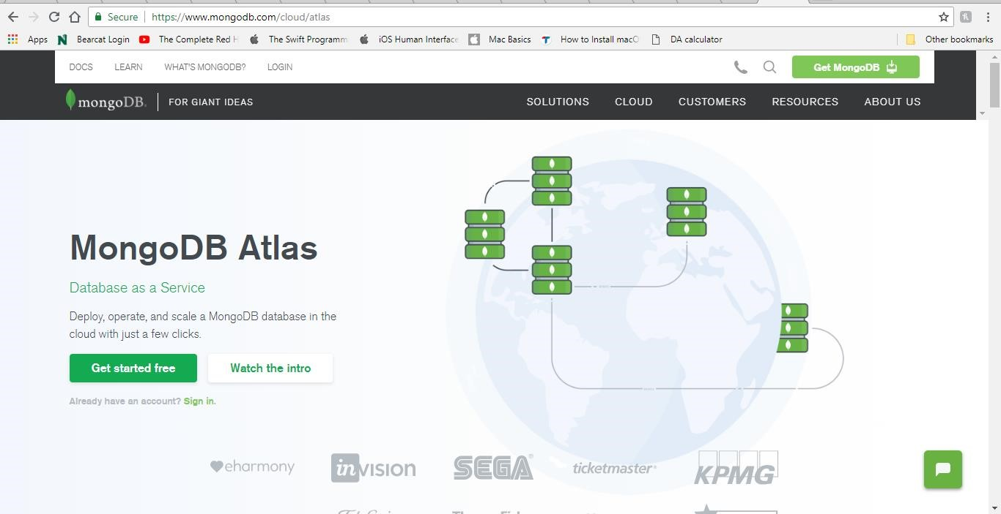

1. Click on ***get started free*** button
2. Enter the details and complete the registration

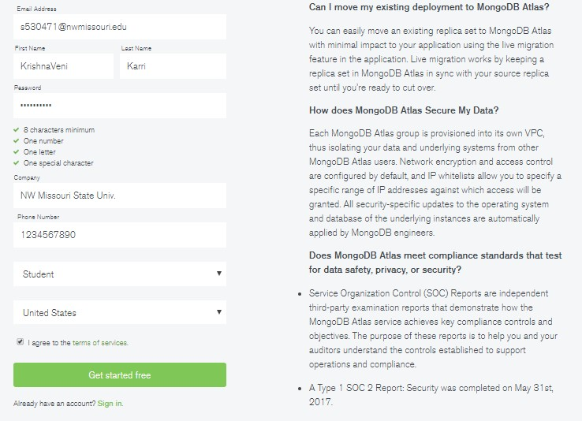

1. Click on create cluster button which is on the rite bottom as shown in the below figure HIGHLITED IN RED

**NOTE: please make sure you are selecting free services. DONOT CHANGE ANY DEFAULT SELECTIONS.**

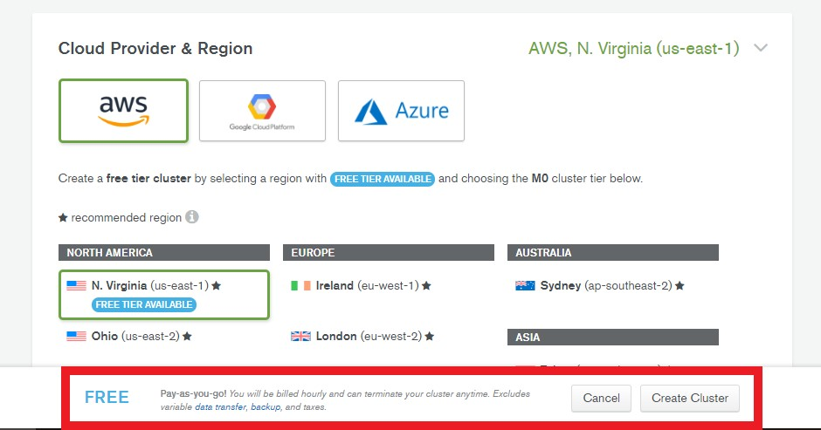

1. You will see below page. The cluster is being created page. This will take up to 15 minutes.

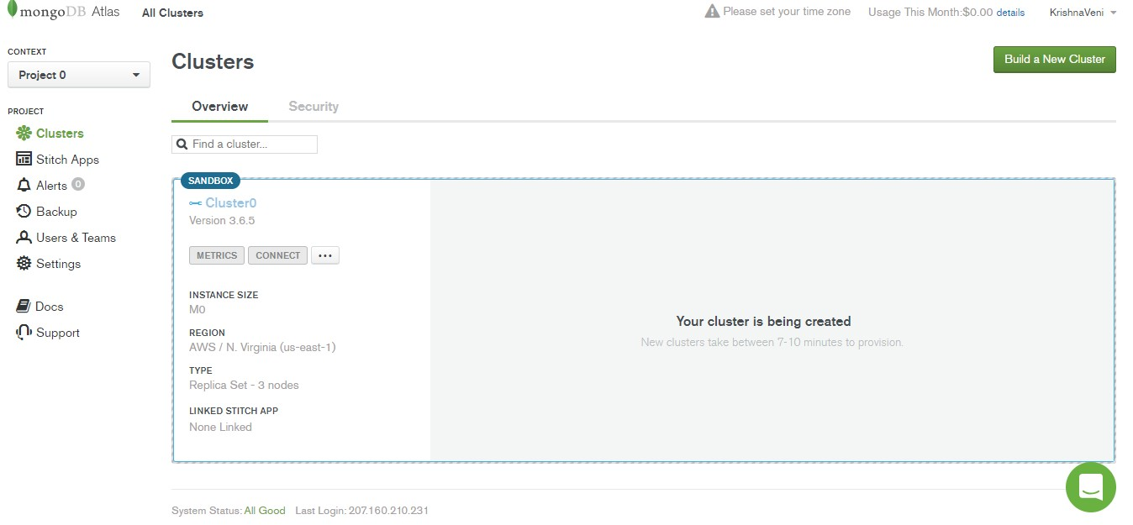

1. This will be the final screen

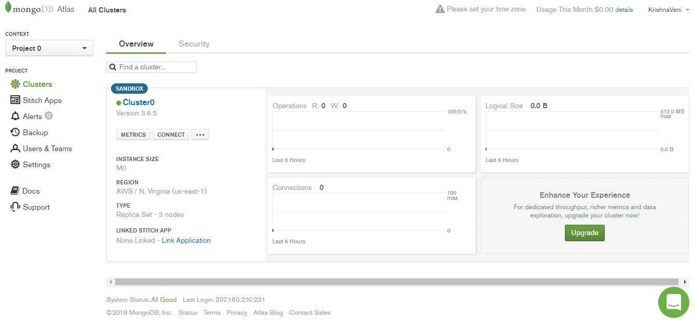

**Mongodb Compass installation guide**

1. Go to the link : <https://www.mongodb.com/download-center?jmp=hero#compass>
2. Click on download button.

**NOTE: PLEASE MAKE SURE TO INSTALL THE SAME VERSION (1.13.1) AS SHOWN BELOW PICTURE**

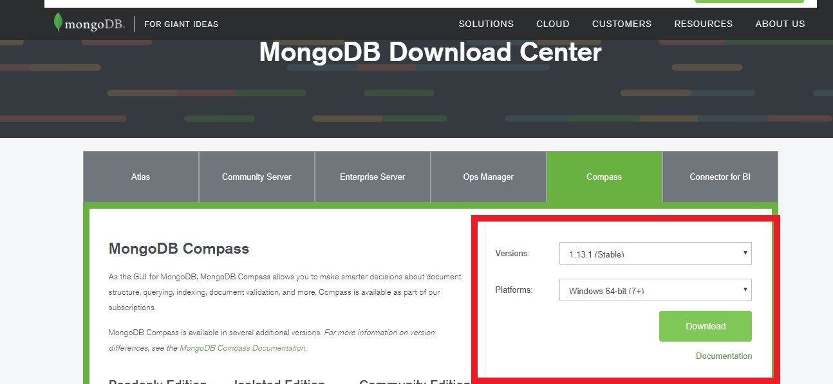

1. Open the exe file you downloaded proceed with installation (it is pretty simple and obvious). In the end you can use the below screen.

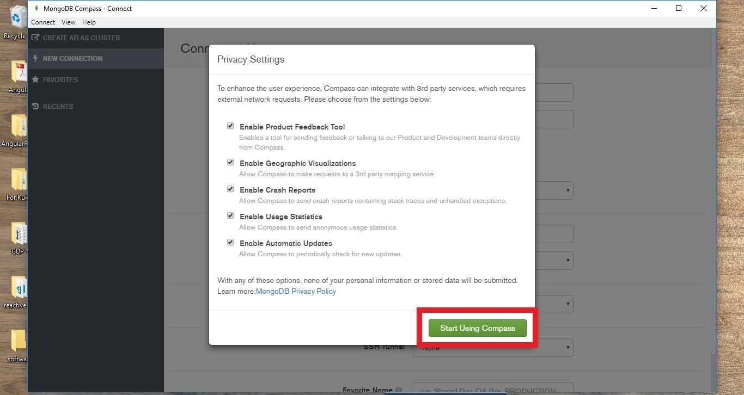

**NodeJS Installation guide**

1. Go to Link: <https://nodejs.org/en/download/>

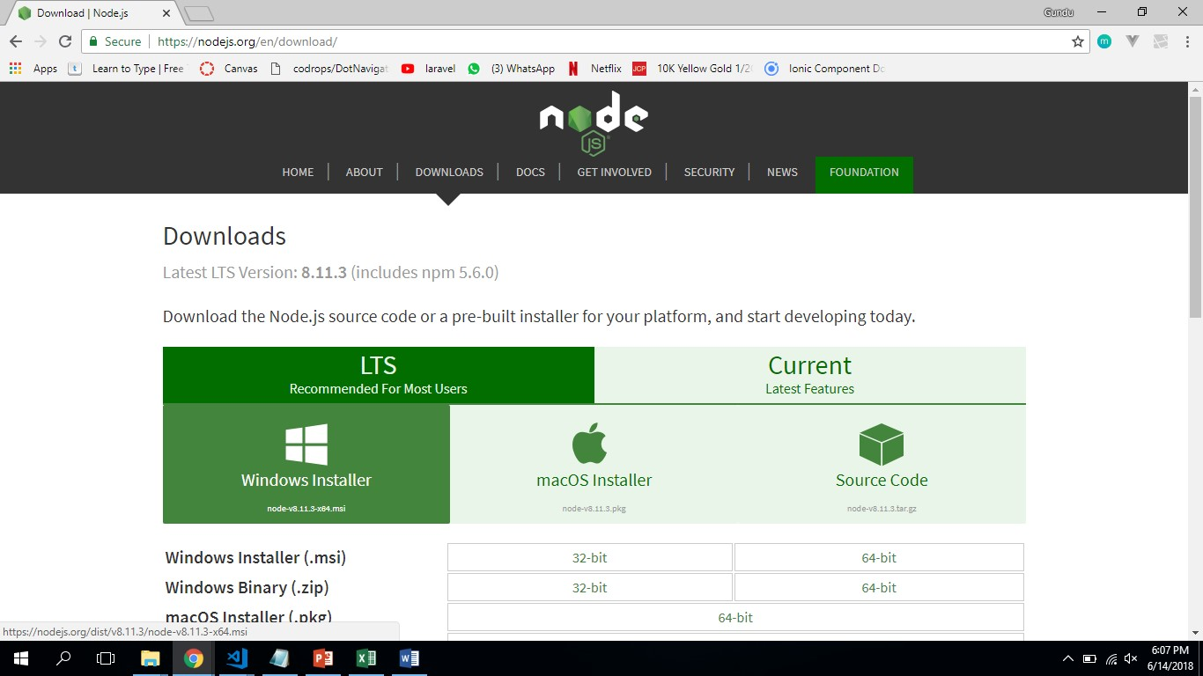

1. Select Windows Installer and you will be able to notice a file starts downloading.
2. Open and setup the downloaded file.

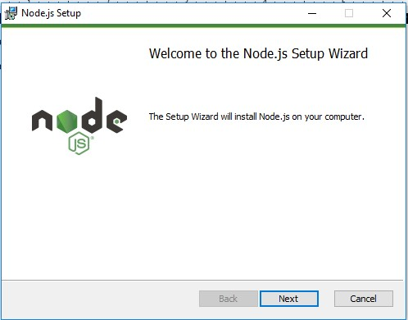

1. Proceed till you install the NodeJS

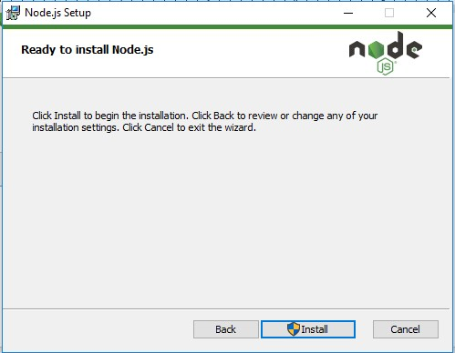

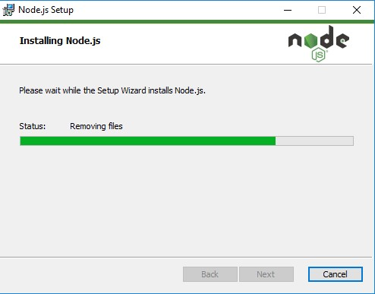

1. After setting up the NodeJS you will be able to see the below screen

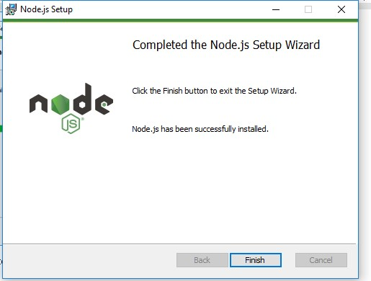

**Installation steps for PostMan**

1. Go to Link: <https://www.getpostman.com/>

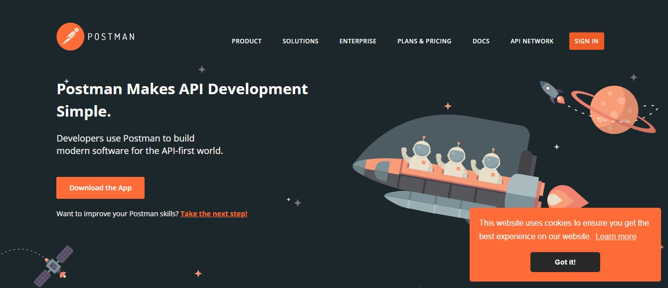

1. Click on the Download the App button

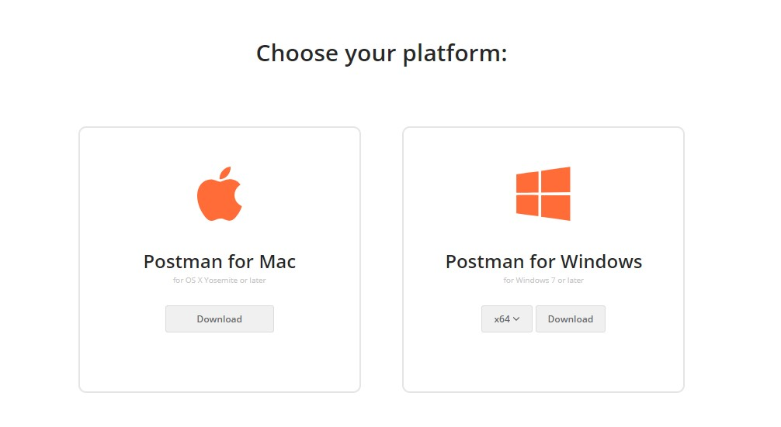

1. Select Windows platform
2. A file starts downloading
3. Open the downloaded file

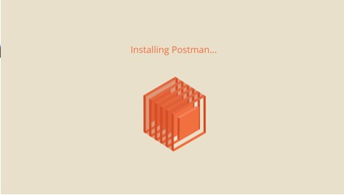

1. Then a popup window as show below will appear

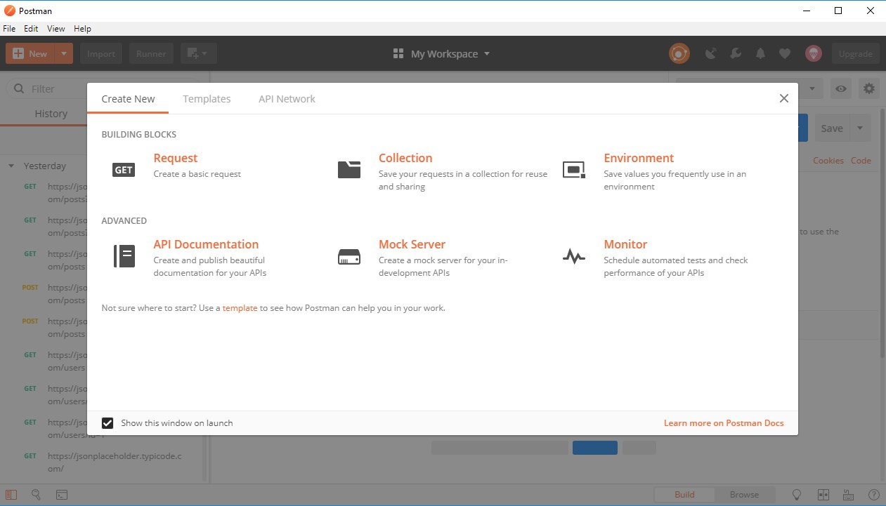

Dependencies(npm libraries) runs on top of NodeJS so it isn't installed directly on Windows, it's added via NPM (Node Package Manager) when you run "npm install" for an application, "npm install" looks at the dependencies section of a MEAN stack application's package.json file and downloads everything required.

**Visual Studio Code**

* 1. Download and install visual studio code from the below link <https://code.visualstudio.com/>

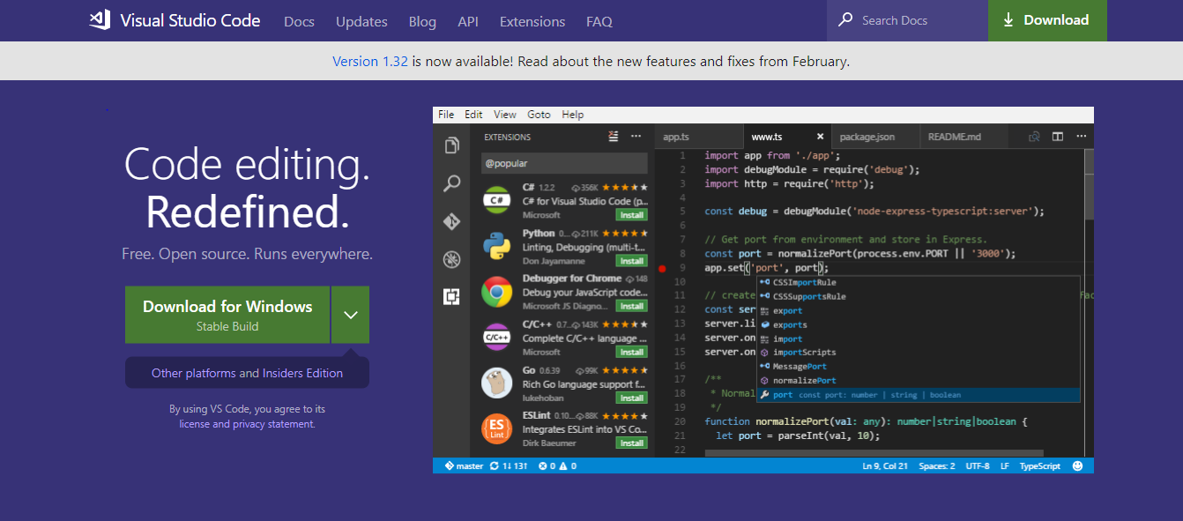

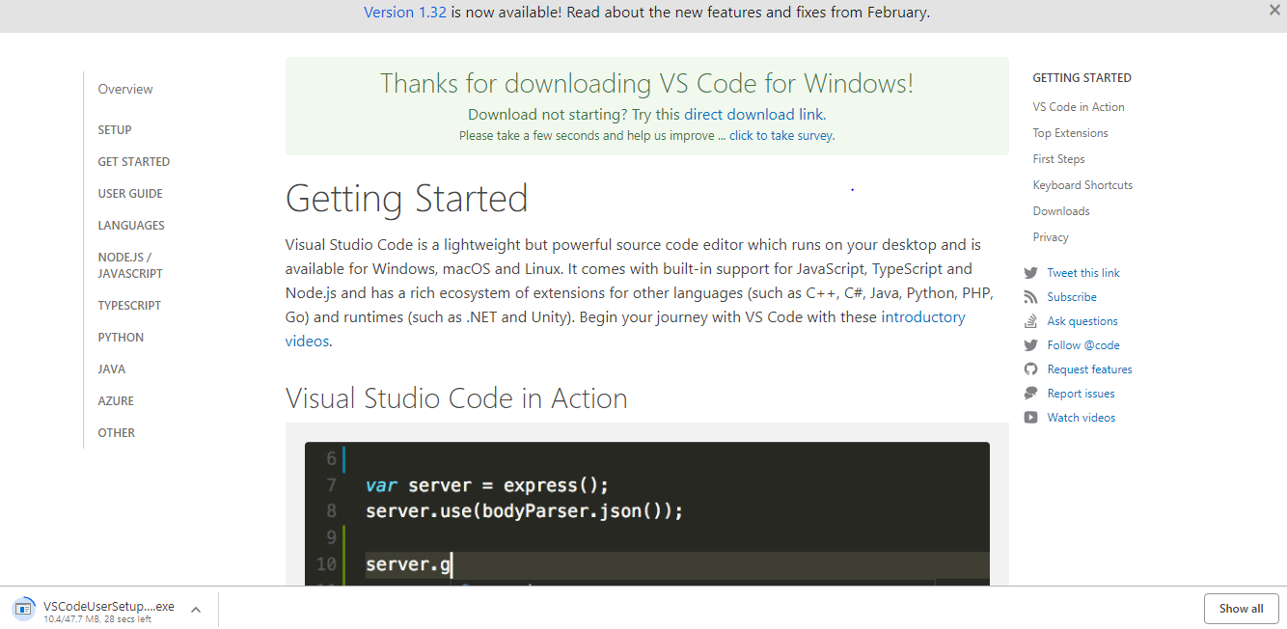

* 1. After downloading open the .exe file for installation. The Setup wizard appears.

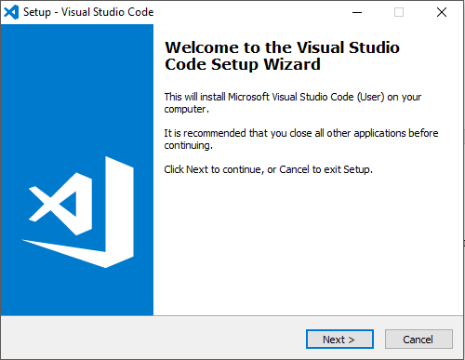

* 1. In setup wizard click on next and then accept the license agreement, click next to continue.

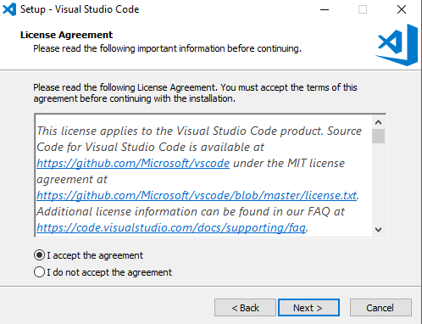

* 1. Give path where you want visual code to be installed

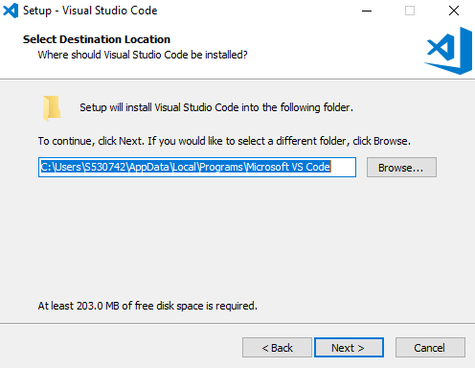

* 1. Select if you want to create a Start Menu Folder for Visual Studio Code and then to proceed click on Next.

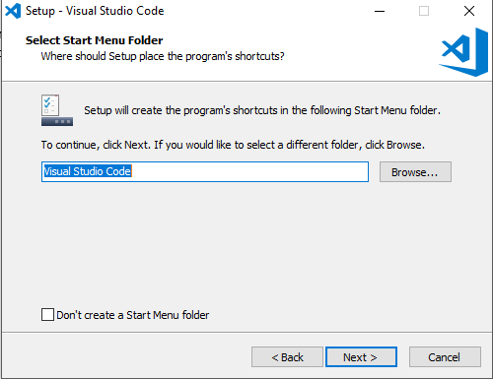

* 1. In Select Additional Tasks Dialog Box, check all the boxes and click on Next to continue.

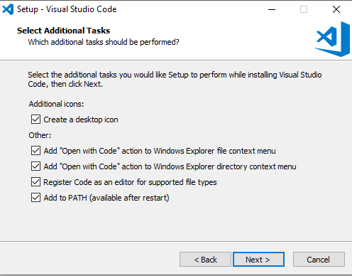

* 1. Click next to install

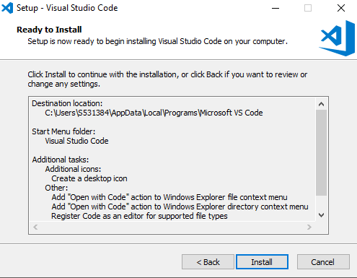

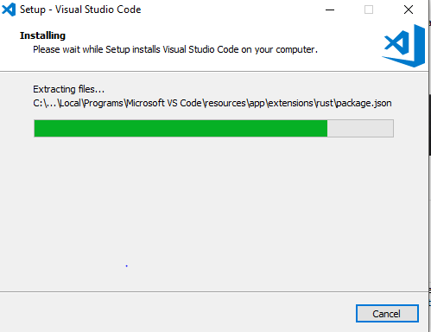

* 1. After successful Installation, Click Finish

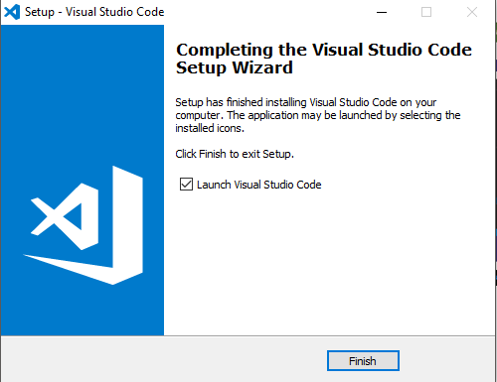

**Set up the Development Environment**

Install the Angular CLI globally.

npm install -g @angular/cli

**Steps to run application**

1. Right on the folder and click open in visual studio code.
2. In the visual studio go to the Terminal and click on new Terminal then type the following command to connect the backend.
   * + npm start
3. Open the new terminal then type the following commands to run the project
   * + cd views
     + ng serve --open